DAY-1 SUMMARY

Introduction to Data Warehousing:

Data warehousing is the process of collecting, storing, and managing large volumes of data from various sources to support analysis and decision-making. It involves the use of specialized systems that integrate, cleanse, and organize data for efficient querying and reporting. Data warehouses typically employ a star or snowflake schema to optimize performance. This framework enables organizations to gain insights and drive strategic actions based on historical and current data.

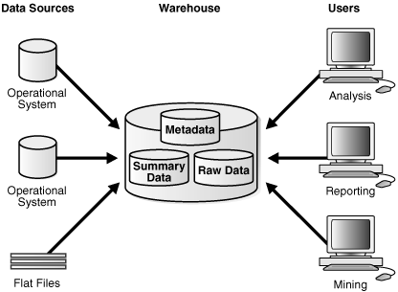

Purpose of Data Warehousing:

The purpose of data warehousing is to centralize and organize vast amounts of data from diverse sources to facilitate reporting and analysis. It provides a reliable environment for business intelligence activities, enabling organizations to uncover insights and trends. Data warehousing enhances data consistency and quality, supporting informed decision-making. Ultimately, it helps drive strategic initiatives by transforming raw data into actionable information.

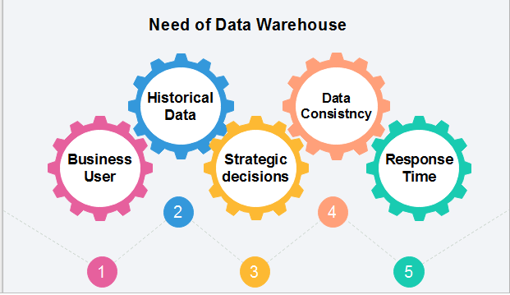

Data Warehouse Architecture:

Data warehouse architecture consists of three main components: data sources, the data warehouse itself, and front-end tools for analysis and reporting. The architecture often includes an extraction, transformation, and loading (ETL) process to integrate data from various sources. It typically features a centralized repository that supports structured and unstructured data storage. This design allows for efficient data retrieval and analytics, enabling organizations to make data-driven decisions.

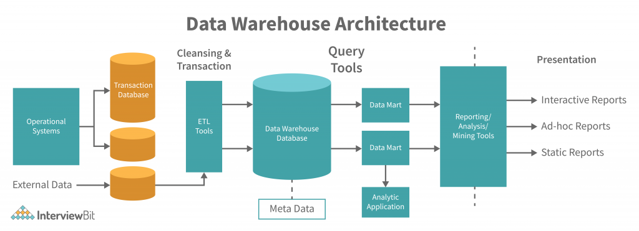

Operational Data Store:

An Operational Data Store (ODS) is a database designed to support daily operations by providing a real-time, integrated view of transactional data. It serves as an intermediary between operational systems and data warehouses, allowing for quick access to up-to-date information. ODS systems are optimized for short-term queries and data updates, facilitating timely decision-making. They play a crucial role in ensuring data consistency and supporting business processes.

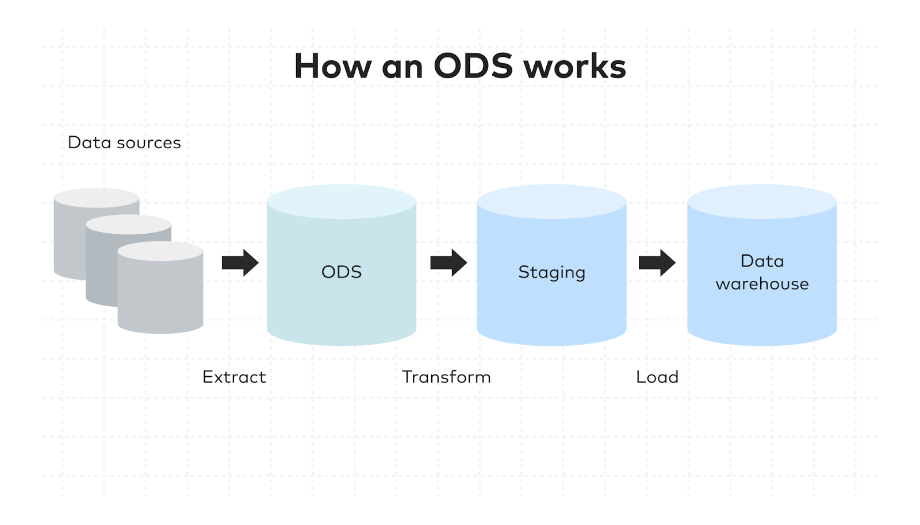

OLTP V/S Warehouse Applications:

Online Transaction Processing (OLTP) systems are designed for managing real-time transactional data, focusing on fast query processing and data integrity for day-to-day operations. In contrast, data warehouses are optimized for analytical processing, supporting complex queries and data analysis over large volumes of historical data. While OLTP systems prioritize quick insertions and updates, data warehouses emphasize read efficiency and data aggregation. Together, they complement each other, with OLTP handling operational tasks and data warehouses enabling strategic insights.

Data Marts:

A data mart is a subset of a data warehouse, focused on a specific business line or department, providing tailored data for analysis. It contains a curated collection of data designed to meet the needs of a particular group, such as sales or finance, allowing for quicker access and more relevant insights. Data marts can be dependent, sourced from a central data warehouse, or independent, built directly from operational systems. They help organizations manage and analyze data efficiently, supporting decision-making processes at a granular level.

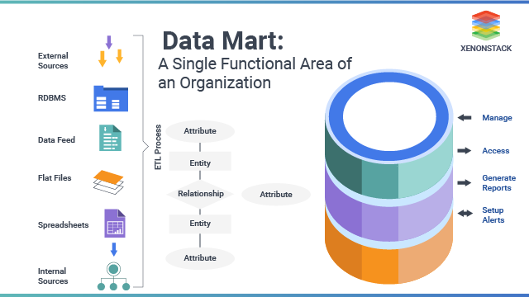

Data Marts V/S Data Warehouse:

A data warehouse is a large, centralized repository that consolidates data from multiple sources across an entire organization for comprehensive analysis and reporting. In contrast, a data mart is a smaller, focused subset of a data warehouse, designed to serve the specific needs of a particular department or business unit. While data warehouses offer a broader, enterprise-wide view, data marts provide quicker access to more relevant data for targeted analysis. Data marts are easier to implement but may lack the holistic perspective of a full data warehouse.

Data Warehouse Life Cycle:

The data warehouse life cycle involves several key stages: \*\*planning\*\*, where the requirements are defined and a strategy is formed; \*\*data modeling and design\*\*, where data structures and architecture are created; \*\*ETL (Extract, Transform, Load)\*\*, where data is collected, processed, and loaded into the warehouse; and \*\*deployment and maintenance\*\*, where the system is implemented, and ongoing support ensures data accuracy, updates, and performance optimization. Throughout this cycle, continuous monitoring and enhancements are performed to meet evolving business needs.

